**Geographic Diversity of Citations**

***- Leelu Chowdary Ravi***

This code works for Harvard referencing style publications: *Last name, First Initial. (Year published). Title. City: Publisher, Page(s).*

The extracted text document has one term in each line.

The reference blocks are separated by two blank lines.

To run the code:

Install Flask and scholarly using pip:

$ pip install Flask

$ pip install scholarly

other packages needed: re, io, sys & requests

* cd in to the folder
* **export FLASK_APP=browser.py**
* **flask run**

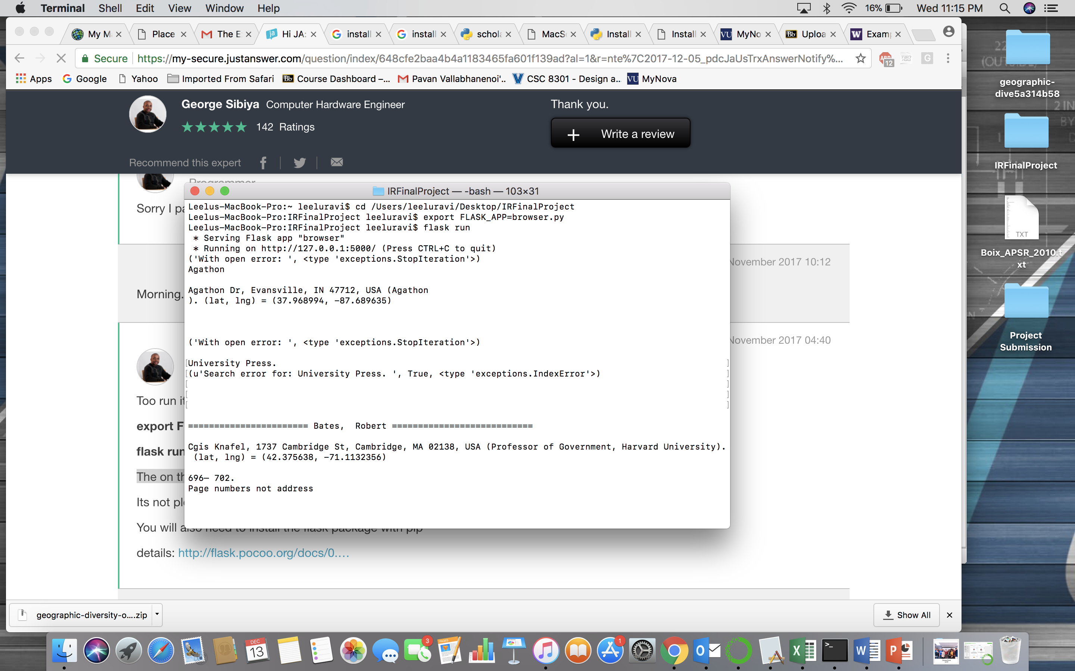

* Copy the url <http://127.0.0.1:5000/> on the browser

It will take a couple of minutes to plot the pins on map. The results will also be populated in the terminal while the code runs.

🡪 Another way to visualize results

* Go to  [**www.arcgis.com**](http://www.arcgis.com)then click Map
* Drag and drop the CSV files (**PUBLISHED JOURNAL LOCATIONS** and **AUTHOR AFFILIATIONS**) and view it as a heat map

Slides were made in Prezi. Included the **Slides.pdf** and also a zip file **geographic-diversity-of-citations-Prezislides.zip** of portable Prezi.